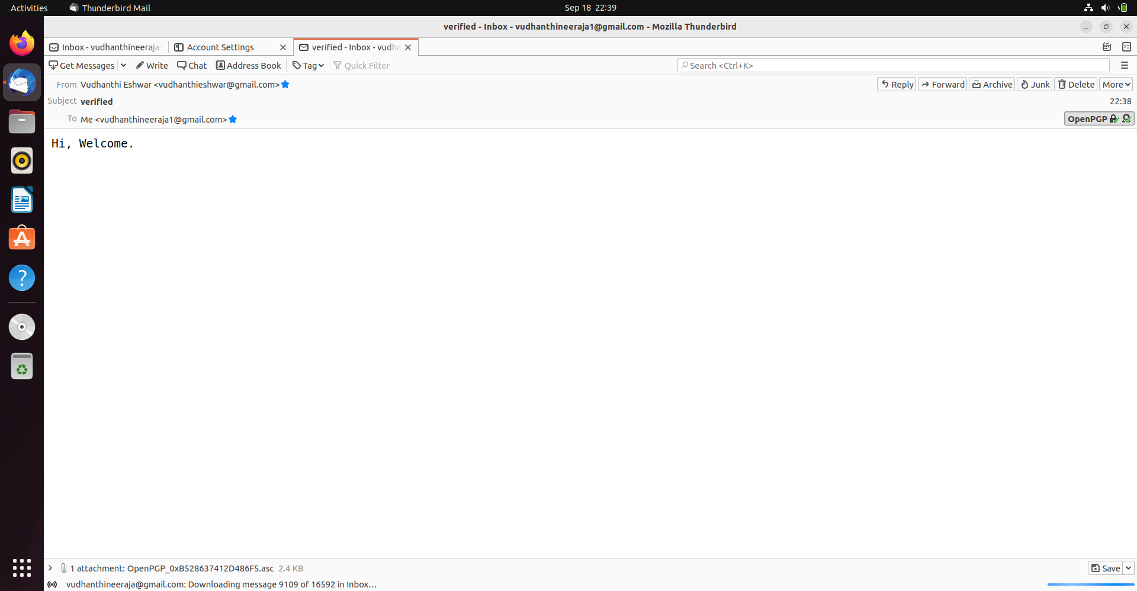WEEK 2: ASSIGNMENT: PERFORMING THE PGP (PRETTY GOOD PRIVACY) EMAIL ENCRYPTION:

